**LAB VENUE:**

**DIGITAL ELECTRONICS LAB @ E4-03-07**

**LAB SCHEDULE:**

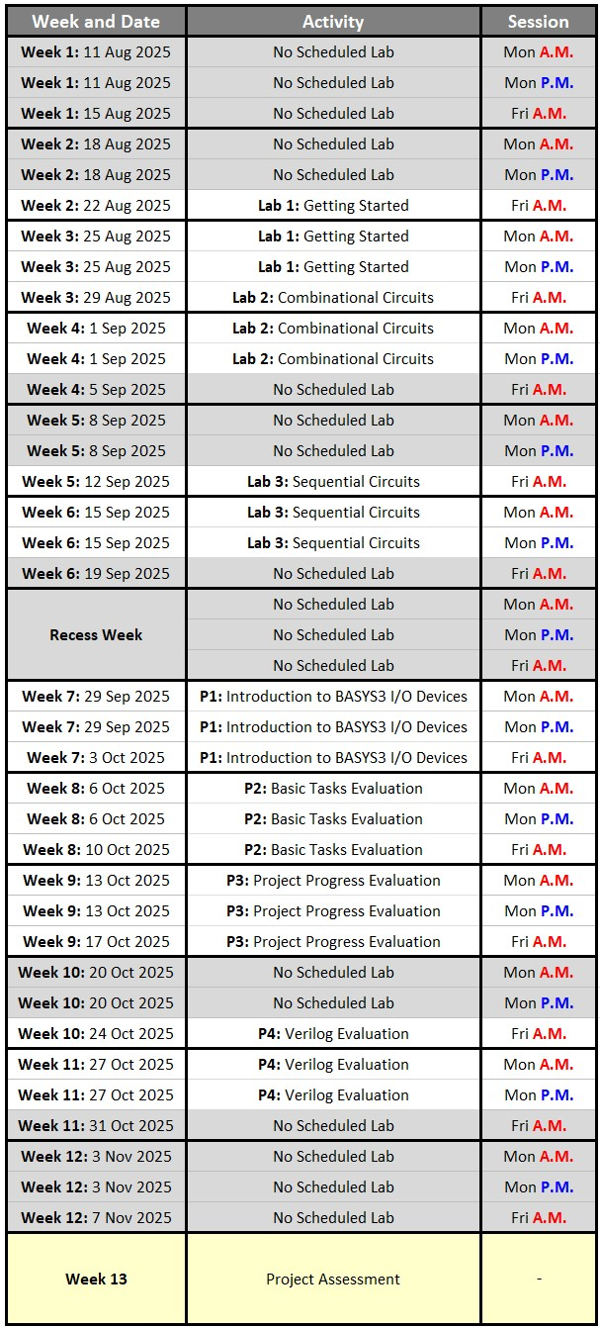

**All the labs have graded assignments that need to be completed before the next lab.**

**Delaying any of these assignments will make all subsequent labs exponentially more difficult to manage!**

**EE2026: DIGITAL DESIGN**

**Academic Year 2025-2026, Semester 1**

**LAB 1: Quick Start Guide to Vivado 2018.2,**

**Basys 3 Development Board, and Verilog HDL**

**HARDWARE COMPATIBILITY:**

* Vivado 2018.2 allows for **Basys3** **hardware connection** only on Intel or AMD x86/x64 based processors, and using Windows. It will not allow Basys3 hardware connection on ARM based processors (Such as Apple’s M1, M2, M3 etc. processors).

* Virtualisation of windows, or non-English character (Eg. Chinese version of windows) Windows, generally have issues with the Basys3 hardware connection also.

**FOR ALL EE2026 LAB AND PROJECT SESSIONS:**

* You are **strongly** **encouraged to bring to lab, your own Windows laptop with Vivado 2018.2 already installed**. You may still use the desktop PC in lab if you do not have a **windows laptop (With x86/x64 processors)** that can be brought to lab.

* Use the **D:\MyWork** folder for your work if you are using the lab PC. You are required to **delete** all folders within the **D:\MyWork** folder before starting your lab session.

* **Delete** your work folder from the laboratory’s computers after your session is over. You are responsible to **safeguard** your confidential programs. For assessable programs, you will be penalised if two programs with similarities beyond empirical evidence are detected. The source(s) and recipient(s) of plagiarised programs are equally penalised.

**OVERVIEW:**

Using a simple Boolean design problem, an introductory approach to the Vivado software used in EE2026 will be covered. Quick instructions on downloading and installing the Vivado software on your personal computer are provided. The Vivado software is a comprehensive integrated development environment (IDE) for FPGA design flow.

In this lab:

* An introduction to very basic Verilog HDL (Hardware Description Language) is provided.
* The overall process flow of designing, synthesising, simulating and implementing a program is covered.
* Programming Digilent’s Basys 3 development board, which features an FPGA from Xilinx’s Artix-7 family, is illustrated.

**GRADED ASSIGNMENT [CANVAS SUBMISSION: FRIDAY 29th AUGUST 2025, 6:00 A.M.]:**

The graded assignment for lab 1 is required to be started during your first lab session and preferably submitted within the same day. It is thus compulsory to have the Vivado software already installed on your **English-Based Windows laptop with Intel / AMD processors** before the lab session.

Details for the assignment are available at the end of this lab manual.

**VIVADO DOWNLOAD AND INSTALLATION:**

The Vivado 2018.2 software is already installed on the computers in the Digital Electronics Lab, and are ready for immediate usage. Some quick guidelines on installing the required software for EE2026 on your personal computer is provided in this section.

**Software:**

AMD/Xilinx Vivado Design Suite - HLx Editions - 2018.2 [**Jun 18, 2018**]

The direct download link is: **https://www.xilinx.com/member/forms/download/xef-vivado.html?filename=Xilinx_Vivado_SDK_2018.2_0614_1954.tar.gz**

Registration is required only downloads from the AMD/Xilinx website. It is not required for program installation and usage. The file size is more than 17 GB, so it may take many minutes/hours to download.

***Warning:*** *Do not use other versions of the software. Only the* ***Vivado 2018.2*** *Windows version has been tested.*

*Computer compatibility issues will occur with other versions of the software, and assessment of your project may not be possible. This will lead to loss of project marks if your project cannot be assessed.*

# Installation

During the installation phase, you will be given an option on the edition to install. The edition to be installed is:

• Vivado HL WebPACK

For subsequent customisation options, you can leave it to the default settings.

# Post-Installation

Restart your computer before using the Vivado 2018.2 software. You are recommended to **uninstall the “Xilinx Information Centre”** from the Windows control panel as it is not needed. This will prevent unnecessary pop-up messages by Xilinx from appearing.

**DESCRIPTION OF THE SIMPLE BOOLEAN DESIGN TASK**

The following task is required to be implemented on the Basys 3 development board:

* S

## UNDERSTANDING | TASK 1

Complete the truth table for the simple boolean design task:

|  |  |  |  |  |  |
| --- | --- | --- | --- | --- | --- |
| **INPUT** | |  | **OUTPUT** |  | **MINTERM** |
| **A** | **B** | **LED1** | **LED2** | **LED3** |
| 0 | 0 | 0 | 0 | 0 | 𝐴̅𝐵̅ |
| 0 | 1 | 0 | 1 | 0 | 𝐴̅𝐵 |
| 1 | 0 | 1 | 0 | 0 | 𝐴𝐵̅ |
| 1 | 1 | 1 | 1 | 1 | 𝐴𝐵 |

# Deriving an SOP Boolean Equation for the Design Task

Given any truth table with any number of input variables, the sum-of-products (SOP) or product-of-sums (POS) form may be used to write out a Boolean equation for each output variable. Let us use the canonical SOP form for **LED1**:

𝐋𝐄𝐃𝟏=𝑨𝑩̅+𝑨𝑩

**𝐋𝐄𝐃2= 𝐴̅𝐵+𝐴𝐵**

**𝐋𝐄𝐃3= 𝐴𝐵**

**UNDERSTANDING | TASK 2**

Work out the canonical SOP Boolean equations for **LED2** and **LED3**

# Illustrating Logic Expressions by Using a Schematic of Gates

The Boolean equations for **LED1**, **LED2**, and **LED3**, can be implement by using: 2 **NOT** gates, 3 **AND** gates, 2 **OR** gates

60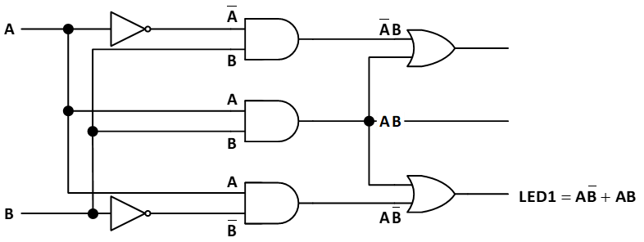

# Verilog Hardware Description and FPGA Implementation

Xilinx’s Vivado software is an integrated design environment that has numerous amounts of advanced features used in the industry, and among which we will be introducing the following:

* Writing and editing HDL codes for digital system designs.
* Simulation of the design’s behaviour.
* Synthesis of the codes, in order to convert the design from textual description into logic gates.
* Implementation of the design to map and route the logic to a target FPGA.
* Optimising the synthesis, implementation, and bitstream generation according to the user’s strategies. The default optimisation strategies shall be used in EE2026, as changing them is beyond the scope of introductory digital designs.
* Programming an FPGA with the optimised bitstream.

The remaining part of this lab manual will now briefly show the general steps required to go from the design task, to the FPGA implementation on the Basys 3 development board, for EE2026 purposes.

# INTRODUCTORY QUICK START GUIDE TO XILINX’S VIVADO 2018.2 SOFTWARE

During your lab session, your EE2026 graduate and lab assistants may provide you helpful hints on the usage of the Vivado 2018.2 software, beyond the most basic things that are described in this section.

## Creating a New Verilog Project in Vivado

**Start Menu:** Open the executable: Vivado 2018.2. You will need to wait multiple seconds before the program opens

**Quick Start:** Select **Create Project** and continue

**Project Name:** Enter a **Project name** and **Project Location**. Ensure that the **Project name** and complete **Project location** for your project folder does not have any spaces or special characters, and that your **Project name** does not start with a number

**Project Type:** Select **RTL Project**, and uncheck “**Do not specify sources at this time**”

**Add sources:**

* **Create File.** File type is Verilog. Example: simple_boolean
* **Target language:** Verilog. **Simulator language:** Mixed

**Add constraints (optional):** Click on next without any changes

**Default Part:** Specify the FPGA chip that will be used. The Basys 3 development board uses the **xc7a35tcpg236-1** chip



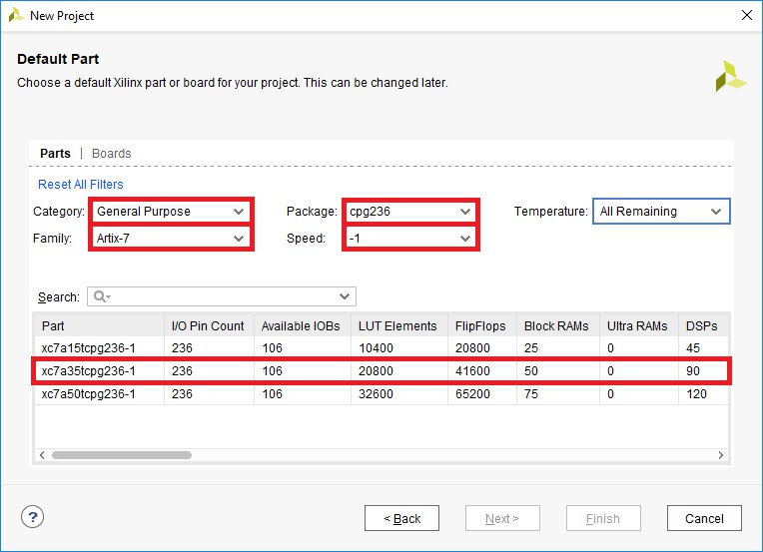

**New Project Summary:** To create the project, click **Finish**

**Define Module:** A module, that is contained within the file, need top be created. Create one based on the inputs and outputs of the simple boolean design task.

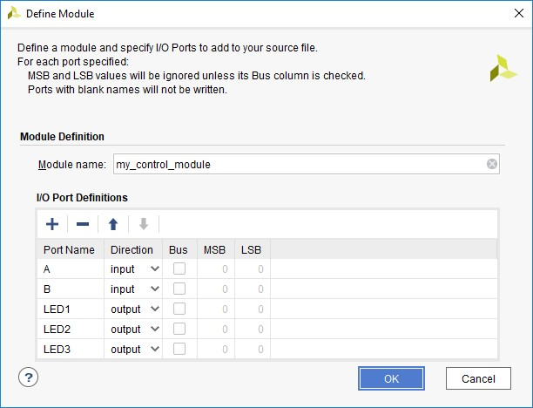

## Using Vivado Text Editor to Write Verilog HDL Code

Open the module that has been created by double clicking on it in the Sources window

### UNDERSTANDING | TASK 3

Code the behaviour of the module by converting the SOP expressions for **LED1**, **LED2**, and **LED3** to the Verilog equivalent. The codes are to be inserted between the keywords **module** and **endmodule**.

Some Verilog representation of common operators are as tabulated below:

|  |  |  |
| --- | --- | --- |
| **Operators** | | **Verilog Representation** |
| OR | 𝐀+𝐁 | | |
| AND | 𝐀𝐁 | & |
| NOT | 𝐀̅ | ~ |
| XOR | 𝐀⊕𝐁 | ^ |

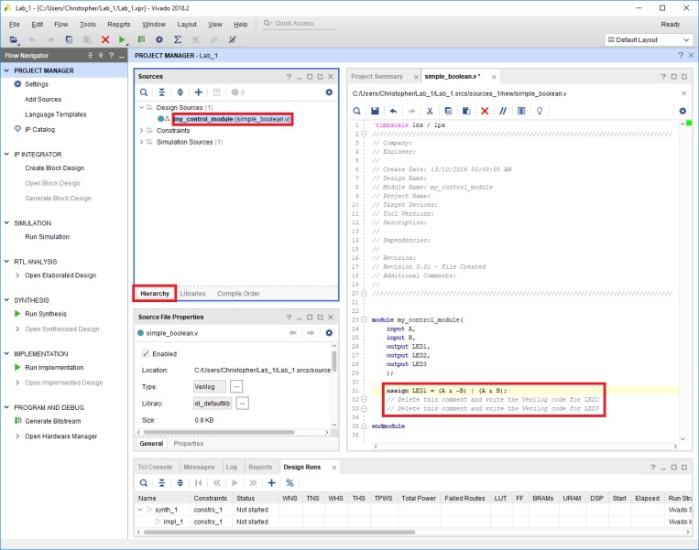

The **assign** statement causes the left hand side of the expression to be updated *every* time there is a change on the right hand side of the expression. It is therefore called a *continuous assignment* statement, describing combinational logic whereby the output on the left is a function of current inputs on the right.

The statements on line 31 till line 33 execute concurrently. This is in contrast to sequential execution of statements in a computer programming language such as C, or procedural assignment that will be taught in subsequent lab sessions.

Save your current file by clicking on **File**  **Save File**, or by pressing **Ctrl+S**. Each time a file is saved, a syntax check is carried out. After saving, perform the following: In the **Flow Navigator** window, under **RTL ANALYSIS**: **Open Elaborated Design**, select **Schematic.** The schematics window will appear, showing the Register Transfer Level (RTL) schematic of the design.

### UNDERSTANDING | TASK 4

What similarities and differences do you notice between the RTL schematic and the schematic obtained from the previous section. How do they compare to the actual schematic obtained on your computer screen?

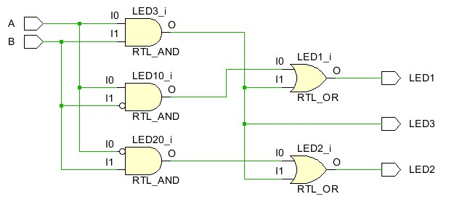

## Testbench and Behavioural Simulation

After writing the codes, there is a need to test them to check their behaviours. Inputs are applied to a module, and the outputs are checked to verify whether the module operates as intended. A testbench is an HDL module that is used to test another module. In this example, a testbench will be created to apply inputs to the module to be tested:

* From the **PROJECT MANAGER**, click on **Add Sources**, followed by **Add or create simulation sources**
* **Create File**, and provide a Verilog file name, such as **test_simple_boolean**
* In the subsequent **Define Module** window, provide a **Module name**, such as **my_control_module_simulation**
* Do not input any **I/O Port Definitions**, and click on **OK** to finish creating the simulation module template

From the Sources window, open the simulation file. Then, within the simulation module, provide the following codes and save them, with the final screenshot looking similar to the image shown below:

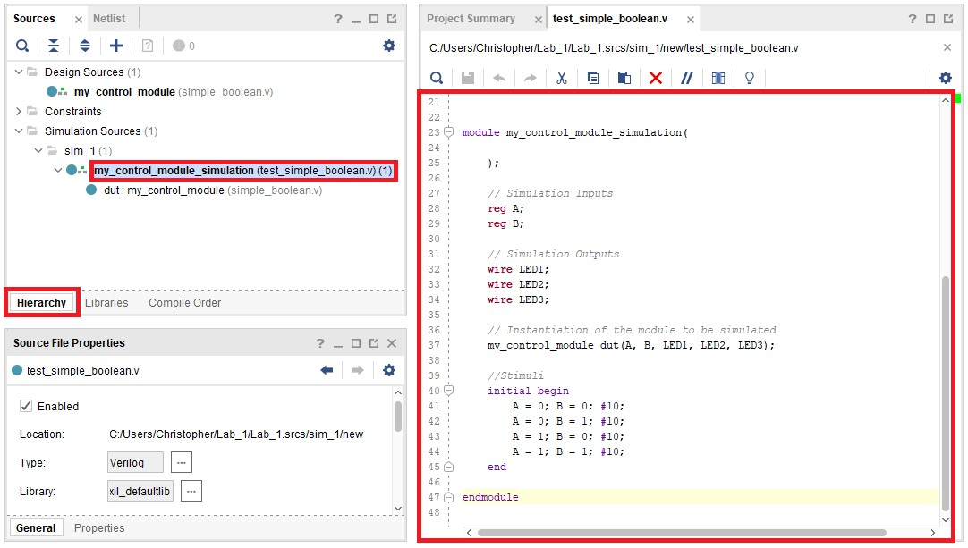

If there are no syntax errors, in the **Flow Navigator** window, under **SIMULATION**, select **Run Simulation**, followed by **Run Behavioural Simulation** in order to create the simulation waveform window.

A noticeable waveform pattern may not be seen by default, as the time resolution used in the simulation is very small as compared to the amount of time the simulation is ran. Hence, with the simulation windows being the active window and from the menu, select **View**  **Zoom Fit**, or press **Ctrl+0**

Look at the simulation results closely. How do the waveforms show that your design is indeed working as desired? Consider trying out the various options provided in the simulation window before going back to the Workspace. Do not save the simulation window waveform, as this consumes a large amount of storage space.

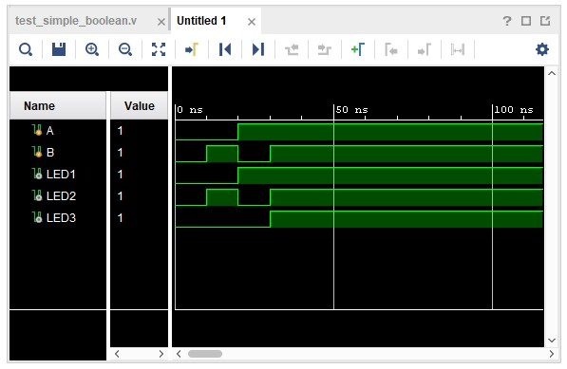

## Synthesis

Logic synthesis transforms HDL code into an optimised set of logic gates to reduce the amount of hardware, and to efficiently perform the intended function.

Right-click on your Verilog design source file and select **Set as Top**. This option is disabled if the file is already the top module, and in such a case, proceed directly to the next step. In general, when there are multiple design and simulation modules, the “Set as Top” option selects the design, or simulation, modules to be considered when performing the different stages of the project flow.

In the **Flow Navigator** window, under **SYNTHESIS**, select **Run Synthesis**. While Vivado performs synthesis, the Project Status Bar at the top right provides an indication of the ongoing progress.

After the synthesis has been successfully completed, in the **Flow Navigator** window, under **SYNTHESIS**, expand **Open Synthesized Design**, and select **Schematics**. The schematic of the synthesised design will be generated and this synthesised circuit is an optimised version of the RTL schematic that was obtained

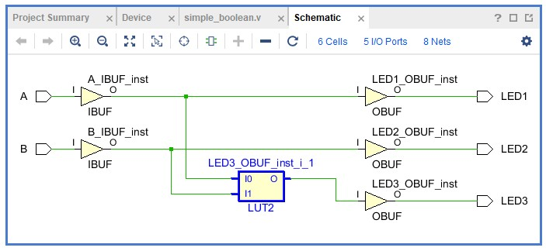

Click on the Look-up Table (LUT) that defines how the output LED3 behaves. The **Cell Properties** window will appear for that specific LUT. In the **Cell Properties** window for the LUT of **LED3**, open the **Truth Table** tab. Notice how for this simple example, this LUT is behaving as a simple AND gate.

### UNDERSTANDING | TASK 5

Compare the optimised and non-optimised schematics. How is this optimised circuit equivalent to the SOP equations of the simple boolean design task?

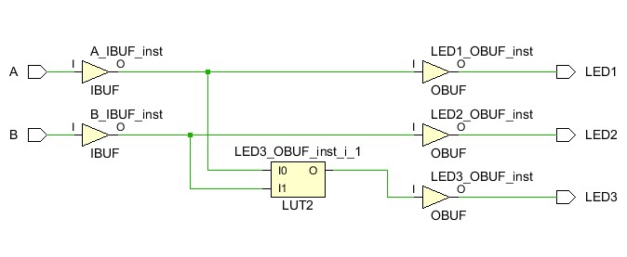

## Design Constraints

Design constraints, such as timing and physical I/O pin mapping, must be defined before doing an implementation, following which the program can be downloaded to the FPGA device. Proceed with the following sequence:

* Expand **PROJECT MANAGER** in the **Flow Navigator** panel, and **click Add Sources**.
* Select **Add or create constraints** and click **Next.**
* Click on **Create File** and give the XDC file a file name, such as **my_basys3_constraints**. The XDC format stands for Xilinx Design Constraints.
* Open the **my_basys3_constraints.xdc** file from the **Sources** window. It will be an empty .xdc file.
* A template, known as the **Basys3_Master.xdc** is provided. Open that template using a basic text editor, such as notepad.
* Copy all the contents from that template to your **my_basys3_constraints.xdc**. All the lines are commented out by default.
* Link the signals (A, B, LED1, LED2, LED3) of your design, to some physical pins of the FPGA, by uncommenting relevant lines.

Input signals can be linked to switches, whereas the output signals can be linked to LEDs, on the Basys3 development board.

An example of the above steps is shown below:

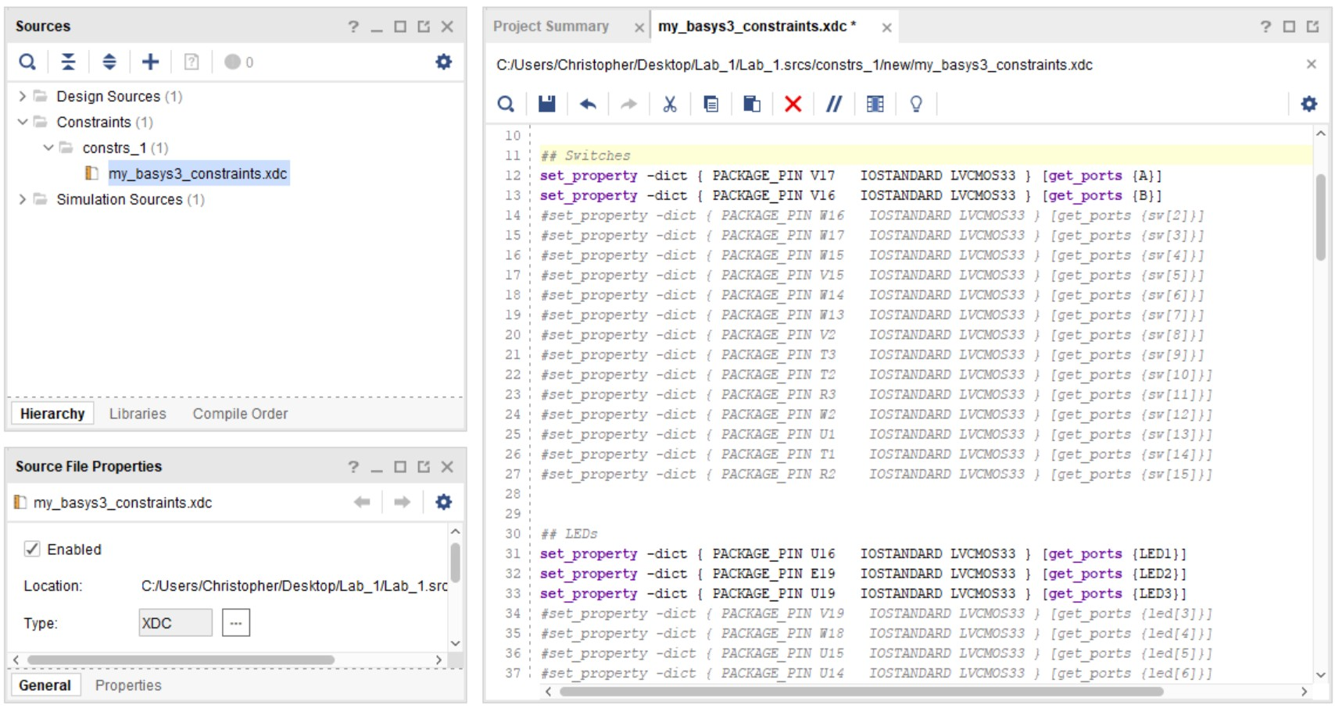

## Implementation, Bitstream Generation and Program Download

The implementation phase will map the design to available physical resources on the FPGA hardware. In the **Flow Navigator** window, under **IMPLEMENTATION**, select **Run Implementation**. This will make use of the design constraint file that had been created earlier on.

After the implementation phase, there is a need to generate a file that can be downloaded to the FPGA. Such a file is called a bitstream file, and it consists of binary values 0’s and 1’s that tells the FPGA how to behave. In the **Flow Navigator** window, under **PROGRAM AND DEBUG**, select **Generate Bitstream**. A successful bitstream generation is the last step required before downloading the program to the FPGA.

Before using your Basys 3 development board, and to prevent potential damage to it, take note of the following recommendations and warnings to extend the longevity of the device:

⚠ Make sure the Basys 3 development board is powered OFF by placing SW16 in the OFF position before connection to/removal from the USB port of the computer.

⚠ Carefully connect to the USB cable

⚠ The chips on the board are electrostatic sensitive. Avoid touching them. Handle the board by the edges to prevent damage.

⚠ Make sure the board is not in contact with any metal components, whether above or below. Do not place any liquid sources near the FPGA board.

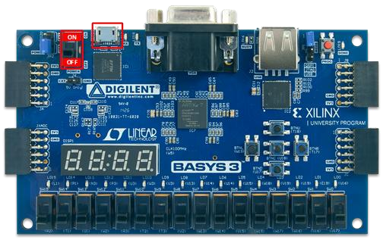

After connection of the Basys 3 development board to the computer, turn on the power by setting SW16 in the ON position. If confirmed to be working, proceed with the following steps:

* Expand **Program and Debug** in the **Flow Navigator Panel**
* Expand **Open Hardware Manager**
* Click **Open Target**
* Select **Auto Connect.** In case connection fails, consider pressing the ‘reset’ button, or turn your device OFF for a few seconds and ON again, while ensuring that it is detected and installed on your computer. Then try **Auto Connect** again
* If successful, the **Program Device** will be enabled, and you will be able to select **xc7a35t_0**
* By default, if the bitstream was successfully generated, the path name in the **Bitstream file** is automatically provided
* Download the .bit file to the FPGA by clicking on **Program**

### UNDERSTANDING | TASK 6

Your program will then be downloaded to the FPGA. Verify the functionality of the design by using the input devices you have assigned to A, B, and observing the output devices assigned to LED1, LED2 and LED3. Check what happens if the ‘reset’ pushbutton on the Basys 3 development board is pressed, or if power is loss for a short amount of time.

**CLOSING NOTES FOR LAB 1**

Now that you have successfully completed your FPGA design flow, one final practice task is provided to you for completion before ending the lab session. This practice task is not graded.

### FINAL UNDERSTANDING | PRACTICE TASK FOR LAB 1

* **Create a new Vivado project from scratch. Do not reuse your existing project or design**

* The same design as described for the simple boolean design task need to be implemented, with the following exception: There is an additional switch C, and if this switch C is in the OFF state, it forces all the three LEDs to be in the OFF state. If the switch C is in the ON state, the design behaves exactly as described for the simple boolean design task. The switch C is to be mapped to SW[*Your birthday month + 3*] on the Basys 3 development board

* Simulate your design, as well as implement it on the Basys 3 development board

**BEFORE STARTING ON THE GRADED ASSIGNMENT:**

**Each student has a personalised requirement based on student matriculation number. Carefully write down your number, as mistakes in the student matriculation number are not accepted:**

7th Rightmost 6th Rightmost 5th Rightmost 4th Rightmost 3rd Rightmost 2nd Rightmost 1st Rightmost Rightmost

Number Number Number Number Number Number Number Alphabet

|  |  |  |  |  |  |  |  |  |
| --- | --- | --- | --- | --- | --- | --- | --- | --- |
| **A** | **0** |  |  |  |  |  |  |  |

Five Rightmost Numerical Values (Subtask B)

Students are required to carefully read all the assignment requirements, and to enhance their understanding by looking at the example.

Marks are given for using your correct student matriculation number, and grading is done only once. Re-submissions, late submissions, or updates, even if very simple or minor, are **not accepted** after the grading.

**GRADED POST-LAB ASSIGNMENT**

Complete as much as possible, in **ONE working bitstream for this whole assignment**. It is much better to have a working program with some completed functionalities, instead of submitting a program without a working bitstream (No marks given).

### IMPORTANT CHARACTERS

In this assignment, these are the important characters to note from your student matriculation number:

* The rightmost alphabet of your student matriculation number (Initialistion)
* The five rightmost numerical values of your student matriculation number (Subtask B) • The 1st rightmost numerical value of your student matriculation number (Subtask B)

### INITIALISATION

When the program starts, all 16 active-high switches (SW0 to SW15) are in the OFF position. All 16 active-high LEDs (LD0 to LD15) are also OFF. The seven segment displays must automatically display the **rightmost alphabet** of your student matriculation number on all the 4 (four) anodes of the 7-segment displays. The character must be displayed **exactly** as indicated (Decimal point is OFF):

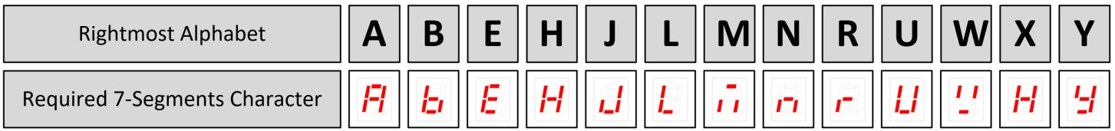

### SUBTASK A

Consider the 10 (ten) switches SW0 to SW9 (Ignore SW10 to SW15). Whenever any of these 10 switches are ON, the corresponding LED LD**X**, where **X** is a number ranging from 0 to 9, must be ON. (For example, if SW0 is ON, then LD0 must be ON. If SW3, SW7 and SW9 are ON, then LD3, LD7 and LD9 must be ON.) **Do not put constraint to SW10 to SW15, and LD10 to LD15.**

### SUBTASK B

Continuing from SUBTASK A, create your personal student matriculation number password based on the **five** **rightmost numerical values** **of your student matriculation number**.

These five digits (May be less than five digits if you have duplicate numbers) will represent the switches that need to be ON, while all the other switches between SW0 to SW9 must be OFF, to be considered a correct password. Whenever the password is wrong, all the 4 (four) anodes of the 7-segment displays show the **rightmost alphabet**. (For example, if all the ten switches SW0 to SW9 are turned ON, that is considered as a wrong password)

Whenever the password entered by the user is the correct password, then instead of all the 4 (four) anodes of the 7-segment displays showing your rightmost alphabet, only specific anodes of the 7-segment displays must show that alphabet. The specific anodes on which the character should be displayed is dependent on the **1st rightmost numerical value** of your student matriculation number, as indicated in the table below:

|  |  |  |  |  |  |  |  |  |  |  |  |  |  |  |  |  |  |  |  |  |  |  |  |  |  |  |  |  |  |  |  |  |  |  |
| --- | --- | --- | --- | --- | --- | --- | --- | --- | --- | --- | --- | --- | --- | --- | --- | --- | --- | --- | --- | --- | --- | --- | --- | --- | --- | --- | --- | --- | --- | --- | --- | --- | --- | --- |
| |  | | --- | | 1st Rightmost  Numerical Value | | **0 , 1** | | **2 , 3** | | **4 , 5** | | **6 , 7** | | **8 , 9** | | |  | | --- | | Anode AN3 | | **ON** | | **ON** | | **ON** | | OFF | | OFF | | |  | | --- | | Anode AN2 | | OFF | | OFF | | **ON** | | **ON** | | **ON** | | |  | | --- | | Anode AN1 | | OFF | | **ON** | | OFF | | **ON** | | OFF | | |  | | --- | | Anode AN0 | | **ON** | | OFF | | OFF | | OFF | | **ON** | |

***Note:*** *Marks will* ***not be given*** *if wrong switch constraints are used! If your student matriculation number password has a* ***0****, then it refers to SW****0****. If your student matriculation number password has a* ***1****, then it refers to SW****1****. If your student matriculation number password has a* ***2****, then it refers to SW****2*** *etc…Ensure you have noted down your 5 rightmost numerical values of your student matriculation number accurately for the password.*

### SUGGESTIONS

* Create a new Vivado project for this assignment, instead of continuing from your previous Vivado project.
* This assignment can be fully completed by using SOP / POS expressions.
* This is a warm-up exercise. It is not recommended to use contents not taught in this lab session.
* Simulation is not required in the submission.

### GETTING STARTED WITH THE SEVEN-SEGMENT DISPLAYS

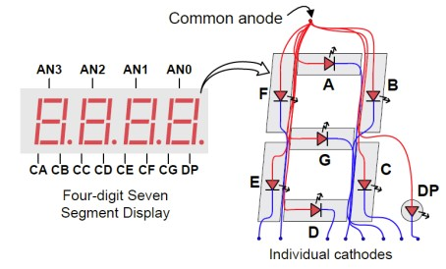There are 7 LED segments in each display, with an additional decimal point segment. They are respectively denoted by “seg[0]” to “seg[6]”, and “dp”, in the Basys_Master.xdc constraint file.

There are 4 seven-segment displays on the Basys 3 development board. Each one of the displays is controlled by a common anode pin, thus resulting in a total of 4 common anodes. These active-low pins are denoted as “an[3]” to “an[0]” in the

Basys_Master.xdc constraint file. (For more information, you can refer to the Basys 3 reference manual, pages 14 to 16)

In your constraint file, it is compulsory to put constraints to the 8 segments (7 segments + decimal point) of the seven-segment display, and to the 4 anodes of the seven-segment display. **Segments or anodes that need to be OFF must explicitly be assigned a value of ‘1’ in your Verilog codes.** For example, if the ‘dot’ segment is required to be off, assign a value of ‘1’ to it.

**EXAMPLE:**

If your student matriculation number is A0159089Y, then:

1st rightmost numerical value: **9** (Means only AN2 and AN0 will be ON if password is correct)

Five rightmost numerical values: **59089** (Means password is SW0, SW5, SW8, SW9)

Rightmost alphabet: **Y**

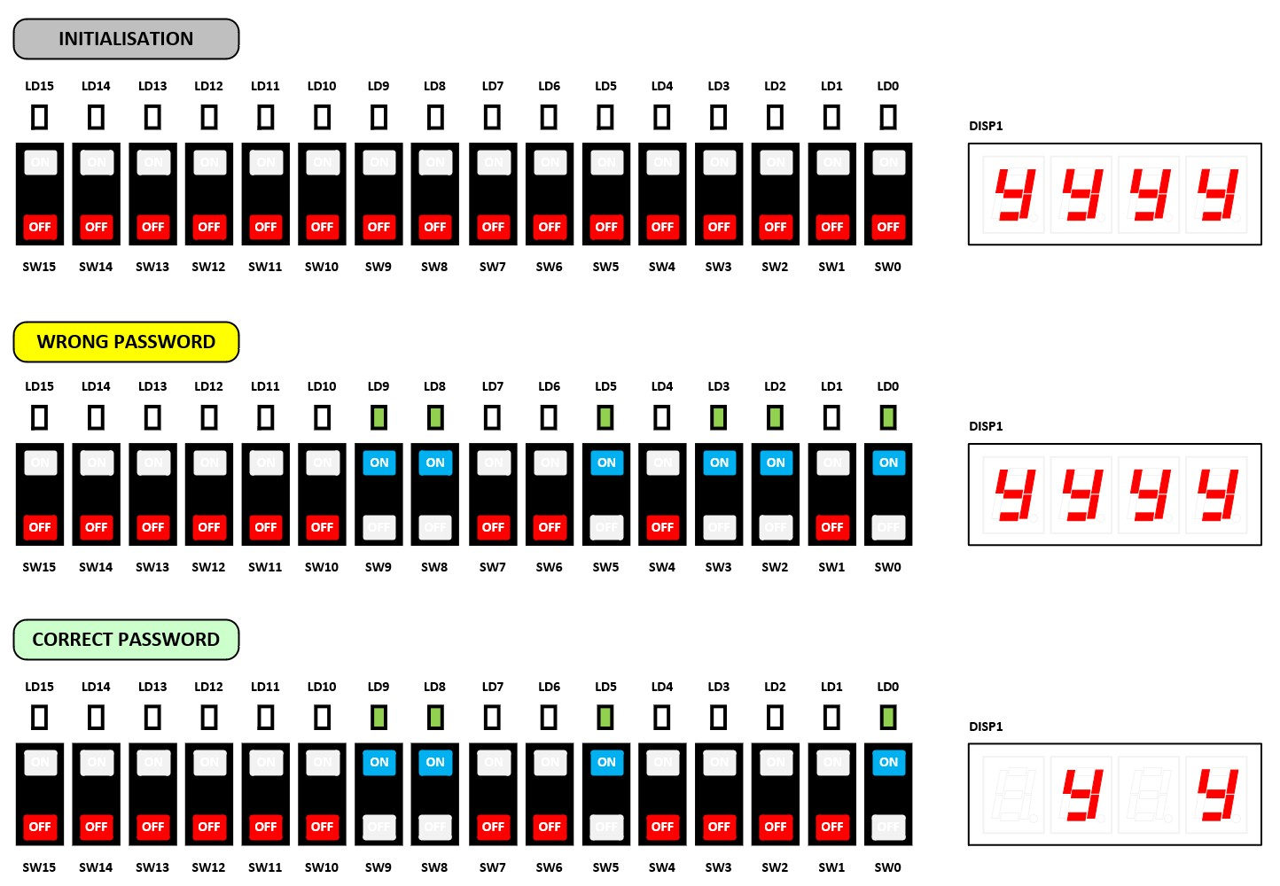

**CANVAS SUBMISSION INSTRUCTIONS**

* Ensure that your bitstream has been successfully generated and tested on your Basys 3 development board **BEFORE** archiving your Vivado workspace for CANVAS upload.

* It is compulsory to archive your project in a compressed form without any saved simulation waveforms. Follow the instructions given in the pdf: “Archive Project in Vivado 2018.02”. **The archive size should not exceed 5 MB in size for any lab assignments.** If the archive size exceeds, ensure that there is no “.sim” folder in your Vivado project folder before archiving.

* **After** following the instructions in “**Archive Project in Vivado 2018.02**”, rename your project archive as indicated in the appendix of this lab manual.

* Upload to CANVAS EE2026 -> Assignments -> Lab 1 Graded Assignment -> Lab 1 Submission (On-Time).

* Download your CANVAS archive after uploading. **Click and drag the single folder within that archive to desktop**, and then open the Vivado project (.xpr) in that **extracted folder** to see if it can be opened. You can ignore “out-of-date” warnings. **Check if you can also run your bitstream correctly.** No project files and no working bitstream is equivalent to losing all marks.

* The CANVAS upload must be completed by **Friday 29th August** **2025, 6:00 A.M. (Morning)**.Avoid planning to upload during the grace period of 2 hours. (Grace period is for last-minute cases, such as due to slow internet, wrong uploads etc.)

* The late submission folder closes 1 week after the original deadline. **Late submissions are not graded if submissions are found in the on-time folder. Do not submit in the late submission folder if you have already submitted in the on-time folder. Inform your lab instructor if you have uploaded in both the on-time folder and late submission folder.** The late submission folder will be located at: CANVAS EE2026 -> Assignments -> Lab 1 Graded Assignment -> Lab 1 Submission (Late).

* Re-submissions, late submissions, or updates, even if very simple or minor, are **not accepted** after your original submission has been graded.

* Submissions through emails, file sharing programs, or links, are **not accepted**. Submissions must be officially submitted to, and downloadable from, Canvas in the correct on-time or late folder.

**Plagiarism is penalised with a 100% penalty for all SOURCES and RECIPIENTS**

All past and future submissions, and marks, will be reviewed in greater detail, for any person found to have plagiarised

**ALL THE SUBMISSION INSTRUCTIONS LISTED ABOVE WILL AFFECT YOUR GRADES!**

_ _ _ _ _ _ _ _ _ __ _ _ _ __ _ _ _ __ _ _ _ __ _ _ _ __ _ _ _ __ _ _ _ __ _ _ _ __ _ _ _ __ _ _ _ __ _ _ _ __ _ _ _ __ _ _ _ __ _ _ _ _ _

## GRADING PROCESS

* During subsequent lab sessions, our graders will be providing you updates on the grading of your submission.

* Submissions not following all the ***CANVAS SUBMISSION INSTRUCTIONS*** (listed above) will not be graded immediately, and they will instead be reviewed towards the end of the semester. **You will not be able to see your submission results during the lab sessions in such situations**.

**APPENDIX (COMPULSORY renaming just before CANVAS upload):**

It is **compulsory to rename your project archive** just before the CANVAS upload, as listed in the table below.

Do not change any other part of the naming. Simply **copy** the naming from the table below, and **paste** it while renaming your project archive. Penalties will be incurred if your submission cannot be found according to the exact naming template below.

CANVAS may automatically add a suffix (Example. “-1”, “-2”, “-3” etc.) at the end of the filename if you submit multiple files. That is acceptable and we will grade the latest file submitted within that on-time folder.

|  |  |
| --- | --- |
| **Name** | **Archive Naming (.xpr.zip and .zip accepted)** |
| AARAV RAJESH | Lab1_Mon_AM_AARAV RAJESH_165_Archive |
| ABE FOO QIAN YIN | Lab1_Mon_AM_ABE FOO QIAN YIN_426_Archive |
| ABHIJIT BALAJEE | Lab1_Mon_PM_ABHIJIT BALAJEE_045_Archive |
| ABIRAMI BASKARAN | Lab1_Mon_PM_ABIRAMI BASKARAN_550_Archive |
| ADIT BISWAS | Lab1_Fri_AM_ADIT BISWAS_789_Archive |
| AFSHAL GULAM | Lab1_Mon_PM_AFSHAL GULAM_376_Archive |
| AHMAD TIRMIZI BIN ADAM | Lab1_Mon_PM_AHMAD TIRMIZI BIN ADAM_523_Archive |
| AIDAN CHIA TONG | Lab1_Mon_PM_AIDAN CHIA TONG_306_Archive |
| ALEXANDER YAW KAI MUN | Lab1_Mon_PM_ALEXANDER YAW KAI MUN_328_Archive |
| ALIYEV ESHGIN | Lab1_Mon_PM_ALIYEV ESHGIN_149_Archive |
| ARIFF MUHAMMED AHSAN HUSAIN | Lab1_Mon_PM_ARIFF MUHAMMED AHSAN HUSA_407_Archive |
| ASHLEE CHANG YEE TING | Lab1_Fri_AM_ASHLEE CHANG YEE TING_686_Archive |
| AW SHUO JIE | Lab1_Fri_AM_AW SHUO JIE_803_Archive |
| AYDEN VAN ETTEN | Lab1_Mon_PM_AYDEN VAN ETTEN_971_Archive |
| BADRINATH SANDHYA | Lab1_Fri_AM_BADRINATH SANDHYA_704_Archive |
| BAE SOOHUN | Lab1_Mon_AM_BAE SOOHUN_652_Archive |
| BAJAJ KRISHNA | Lab1_Mon_PM_BAJAJ KRISHNA_769_Archive |
| BENJAMIN CHEK JUN KIET | Lab1_Mon_AM_BENJAMIN CHEK JUN KIET_381_Archive |
| BENJAMIN LOH JIAN WEI | Lab1_Mon_PM_BENJAMIN LOH JIAN WEI_455_Archive |
| BHADRA PARV | Lab1_Mon_PM_BHADRA PARV_813_Archive |
| BINDAWALA AARAV | Lab1_Fri_AM_BINDAWALA AARAV_779_Archive |
| BRENDAN TEY SHI HAN | Lab1_Mon_AM_BRENDAN TEY SHI HAN_957_Archive |
| BRIEN LIM CHONG | Lab1_Fri_AM_BRIEN LIM CHONG_162_Archive |
| CEDRIC TAN SI YU | Lab1_Mon_AM_CEDRIC TAN SI YU_331_Archive |
| CHAKRABORTY SHRABASTI | Lab1_Mon_PM_CHAKRABORTY SHRABASTI_685_Archive |
| CHAN YI FENG | Lab1_Mon_PM_CHAN YI FENG_824_Archive |
| CHANG YI HERNG | Lab1_Mon_AM_CHANG YI HERNG_612_Archive |
| CHARNG HE | Lab1_Mon_AM_CHARNG HE_580_Archive |
| CHEN GUANWEN | Lab1_Fri_AM_CHEN GUANWEN_978_Archive |
| CHEN HONGYU | Lab1_Fri_AM_CHEN HONGYU_122_Archive |
| CHEN XINGTONG | Lab1_Mon_PM_CHEN XINGTONG_961_Archive |
| CHEN YU HSIN | Lab1_Mon_PM_CHEN YU HSIN_432_Archive |
| CHEO ZHI XIAN MATHEU | Lab1_Fri_AM_CHEO ZHI XIAN MATHEU_851_Archive |
| CHEONG JIAN HAO | Lab1_Mon_PM_CHEONG JIAN HAO_240_Archive |
| CHEW EN WEI | Lab1_Fri_AM_CHEW EN WEI_658_Archive |
| CHIA HAO JUN | Lab1_Mon_AM_CHIA HAO JUN_207_Archive |
| CHIA LE, ISAAC | Lab1_Mon_AM_CHIA LE ISAAC_940_Archive |
| CHNG RUI YONG SEAN | Lab1_Mon_PM_CHNG RUI YONG SEAN_435_Archive |
| CHONG KAI JIE | Lab1_Mon_PM_CHONG KAI JIE_314_Archive |
| CHONG WEIXUAN, CYDRIC | Lab1_Mon_AM_CHONG WEIXUAN CYDRIC_871_Archive |
| CHOY ZHAN HONG | Lab1_Mon_PM_CHOY ZHAN HONG_444_Archive |

|  |  |
| --- | --- |
| CHUA YONG LIANG | Lab1_Mon_AM_CHUA YONG LIANG_014_Archive |
| CUI JIAHAO | Lab1_Fri_AM_CUI JIAHAO_085_Archive |
| DANIEL CHUA ZHENG JIE | Lab1_Mon_PM_DANIEL CHUA ZHENG JIE_443_Archive |
| DENG HAOFU | Lab1_Mon_PM_DENG HAOFU_338_Archive |
| DENY HAANS HAZRIEL BIN ARMADA | Lab1_Mon_PM_DENY HAANS HAZRIEL BIN AR_153_Archive |
| DIWAKAR VIDYA ADHAVAN | Lab1_Mon_PM_DIWAKAR VIDYA ADHAVAN_335_Archive |
| DYLAN LIM | Lab1_Mon_PM_DYLAN LIM_821_Archive |
| EMRY DANIEL BIN ABDUL LATHIFF | Lab1_Mon_AM_EMRY DANIEL BIN ABDUL LAT_550_Archive |
| FOO KANG | Lab1_Fri_AM_FOO KANG_353_Archive |
| GABRA SHUBHAN | Lab1_Mon_AM_GABRA SHUBHAN_258_Archive |
| GABRIEL LEE JING YI | Lab1_Mon_PM_GABRIEL LEE JING YI_006_Archive |
| GAN ANDREW HOA THIEN | Lab1_Fri_AM_GAN ANDREW HOA THIEN_281_Archive |
| GOH ANG LEE | Lab1_Fri_AM_GOH ANG LEE_598_Archive |
| GOH SHAO ANN | Lab1_Fri_AM_GOH SHAO ANN_219_Archive |
| GOH SZE ANH | Lab1_Mon_AM_GOH SZE ANH_325_Archive |
| GOH YOU YI | Lab1_Fri_AM_GOH YOU YI_326_Archive |
| GORDON HONG JIA JIE | Lab1_Mon_PM_GORDON HONG JIA JIE_465_Archive |
| GU MINGYOUJIA | Lab1_Fri_AM_GU MINGYOUJIA_260_Archive |
| GUO ZICHENG | Lab1_Mon_AM_GUO ZICHENG_823_Archive |
| HANNAH WESTERHOUT HASAN | Lab1_Mon_AM_HANNAH WESTERHOUT HASAN_413_Archive |
| HAO YIAN | Lab1_Mon_PM_HAO YIAN_006_Archive |
| HIEW T G | Lab1_Fri_AM_HIEW T G_306_Archive |
| HOWIE YEO HAO YU | Lab1_Fri_AM_HOWIE YEO HAO YU_345_Archive |
| HU LIFAN | Lab1_Fri_AM_HU LIFAN_030_Archive |
| HU XIRAN | Lab1_Fri_AM_HU XIRAN_503_Archive |
| HUANG HAU SHUAN | Lab1_Mon_AM_HUANG HAU SHUAN_356_Archive |
| HUANG YUANJIN | Lab1_Mon_AM_HUANG YUANJIN_080_Archive |
| IAN CHOO TZIE ZHENG | Lab1_Fri_AM_IAN CHOO TZIE ZHENG_747_Archive |
| IRWAN AHMED NOOR | Lab1_Mon_AM_IRWAN AHMED NOOR_184_Archive |
| JAIRUS LEUNG JIE RUI | Lab1_Fri_AM_JAIRUS LEUNG JIE RUI_337_Archive |
| JANSEN KEN PEGRASIO | Lab1_Mon_AM_JANSEN KEN PEGRASIO_566_Archive |
| JAVIER YEOH ZHI JI | Lab1_Fri_AM_JAVIER YEOH ZHI JI_430_Archive |
| JOEL KU | Lab1_Fri_AM_JOEL KU_232_Archive |
| JOEL LIM JUN YI | Lab1_Fri_AM_JOEL LIM JUN YI_423_Archive |
| JOHN KENNETH LAYBA AGPAOA | Lab1_Mon_PM_JOHN KENNETH LAYBA AGPAOA_489_Archive |
| JOSHUA TAM KA YUI | Lab1_Fri_AM_JOSHUA TAM KA YUI_315_Archive |
| JOSHUA YEO WEE TZE | Lab1_Fri_AM_JOSHUA YEO WEE TZE_878_Archive |
| JOVIAN JOSH | Lab1_Mon_AM_JOVIAN JOSH_585_Archive |
| KARTHIK KATHIRESH | Lab1_Mon_AM_KARTHIK KATHIRESH_122_Archive |
| KARTHIKEYAN VETRIVEL | Lab1_Mon_PM_KARTHIKEYAN VETRIVEL_899_Archive |
| KENNETH WONG CUN WI | Lab1_Fri_AM_KENNETH WONG CUN WI_742_Archive |
| KEVIN LOKE WEI YI | Lab1_Mon_AM_KEVIN LOKE WEI YI_957_Archive |
| KHOO JUNHAO | Lab1_Fri_AM_KHOO JUNHAO_052_Archive |
| KOH LI TIAN | Lab1_Mon_AM_KOH LI TIAN_429_Archive |
| KOTHARI SMEET RONAK | Lab1_Fri_AM_KOTHARI SMEET RONAK_661_Archive |
| KUAH JUN HONG, BRYAN | Lab1_Fri_AM_KUAH JUN HONG BRYAN_384_Archive |
| LABELLE LEE | Lab1_Mon_AM_LABELLE LEE_619_Archive |
| LAM ZHEN LEI, ETHAN | Lab1_Fri_AM_LAM ZHEN LEI ETHAN_558_Archive |
| LAU EN XIN, GRACE | Lab1_Mon_PM_LAU EN XIN GRACE_497_Archive |
| LEE KAH HOE, BRIAN | Lab1_Fri_AM_LEE KAH HOE BRIAN_300_Archive |
| LEE KUAN YI | Lab1_Mon_PM_LEE KUAN YI_201_Archive |
| LEONARD LIM TZE YANG | Lab1_Mon_PM_LEONARD LIM TZE YANG_460_Archive |
| LI LINYING | Lab1_Mon_PM_LI LINYING_166_Archive |

|  |  |
| --- | --- |
| LI XIAOYANG | Lab1_Mon_PM_LI XIAOYANG_853_Archive |
| LIM KAI LER, ETHAN | Lab1_Fri_AM_LIM KAI LER ETHAN_939_Archive |
| LIM SWEE HOW GABRIEL | Lab1_Mon_PM_LIM SWEE HOW GABRIEL_173_Archive |
| LIM ZE EN, MATTHIAS | Lab1_Mon_AM_LIM ZE EN MATTHIAS_943_Archive |
| LIU LEKUAN | Lab1_Mon_PM_LIU LEKUAN_703_Archive |
| LIU YIHAN | Lab1_Fri_AM_LIU YIHAN_493_Archive |
| LOH HAN XIANG | Lab1_Mon_AM_LOH HAN XIANG_229_Archive |
| LOU YU | Lab1_Fri_AM_LOU YU_962_Archive |
| LOUIS AGARA PERIN | Lab1_Mon_AM_LOUIS AGARA PERIN_320_Archive |
| LOW ZEN WEI | Lab1_Mon_AM_LOW ZEN WEI_635_Archive |
| LU QIANXI | Lab1_Mon_AM_LU QIANXI_033_Archive |
| LUO HONGXUN | Lab1_Mon_AM_LUO HONGXUN_391_Archive |
| MAHESH PURAV | Lab1_Fri_AM_MAHESH PURAV_679_Archive |
| MANDI SIDDID UMESH | Lab1_Mon_AM_MANDI SIDDID UMESH_173_Archive |
| MANU DAGUR | Lab1_Mon_PM_MANU DAGUR_861_Archive |
| MAO XIAOHAN | Lab1_Mon_PM_MAO XIAOHAN_110_Archive |
| MARK NG JIAN XIONG | Lab1_Fri_AM_MARK NG JIAN XIONG_883_Archive |
| MATHEW SAAYUJ ION | Lab1_Mon_AM_MATHEW SAAYUJ ION_282_Archive |
| MICHAEL SHYAM WILFRED DAVID SAMUVEL | Lab1_Fri_AM_MICHAEL SHYAM WILFRED DAV_218_Archive |
| MO HANQI | Lab1_Mon_AM_MO HANQI_531_Archive |
| MOHAMED FARAS S/O FARIDUL HUK | Lab1_Mon_AM_MOHAMED FARAS SO FARIDUL_806_Archive |
| MUHAMMAD AKMAL HANIS BIN MD JOHANI | Lab1_Fri_AM_MUHAMMAD AKMAL HANIS BIN _123_Archive |
| NAILA FAIQAH BINTE MUHAMMAD AZHAR | Lab1_Mon_PM_NAILA FAIQAH BINTE MUHAMM_406_Archive |
| NAVANEETHAN SANJAI | Lab1_Mon_AM_NAVANEETHAN SANJAI_231_Archive |
| NEERAJ VENGADESSAN | Lab1_Mon_AM_NEERAJ VENGADESSAN_959_Archive |
| NI SHI YONG | Lab1_Mon_AM_NI SHI YONG_596_Archive |
| NICHOLAS LAU HONGYI | Lab1_Mon_PM_NICHOLAS LAU HONGYI_324_Archive |
| NOCHUR SIVANSH | Lab1_Mon_PM_NOCHUR SIVANSH_332_Archive |
| ONG CHONG YAO | Lab1_Mon_PM_ONG CHONG YAO_901_Archive |
| ONG XIANG KAI | Lab1_Mon_AM_ONG XIANG KAI_232_Archive |
| PANG ANG SHENG ASHER | Lab1_Fri_AM_PANG ANG SHENG ASHER_237_Archive |
| PRANAV JANAKIRAMAN | Lab1_Mon_PM_PRANAV JANAKIRAMAN_346_Archive |
| PREMIL ROSHAN | Lab1_Mon_AM_PREMIL ROSHAN_805_Archive |
| PRERANA RAVI SHANKAR | Lab1_Fri_AM_PRERANA RAVI SHANKAR_092_Archive |
| RAJAN PRAVEEN | Lab1_Mon_PM_RAJAN PRAVEEN_146_Archive |
| RAJARAM SUSHMIITHAA | Lab1_Mon_PM_RAJARAM SUSHMIITHAA_309_Archive |
| RAJESH KUMAR ASWIN | Lab1_Mon_PM_RAJESH KUMAR ASWIN_713_Archive |
| REHAAN MAHMOOD | Lab1_Mon_PM_REHAAN MAHMOOD_719_Archive |
| RISHABH RAMPRASAD SHENOY | Lab1_Fri_AM_RISHABH RAMPRASAD SHENOY_597_Archive |
| ROHAN H | Lab1_Mon_AM_ROHAN H_155_Archive |
| ROSHAN ALAGAR PREMKUMAR | Lab1_Mon_PM_ROSHAN ALAGAR PREMKUMAR_245_Archive |
| RUSSELL NG JUN HENG | Lab1_Fri_AM_RUSSELL NG JUN HENG_204_Archive |
| RYAN KOH JUN HAO | Lab1_Mon_PM_RYAN KOH JUN HAO_601_Archive |
| RYAN PANG ZE XI | Lab1_Mon_PM_RYAN PANG ZE XI_453_Archive |
| RYAN TAN RONG CHANG | Lab1_Mon_PM_RYAN TAN RONG CHANG_406_Archive |
| SAMUEL LEE WEN JIN | Lab1_Mon_AM_SAMUEL LEE WEN JIN_232_Archive |
| SANGHI NISHCHAY | Lab1_Mon_PM_SANGHI NISHCHAY_666_Archive |
| SARAVANAN RAJESHWARI AKSHAY PRANAV | Lab1_Mon_AM_SARAVANAN RAJESHWARI AKSH_513_Archive |
| SEAN LEE WEI SHU | Lab1_Mon_PM_SEAN LEE WEI SHU_252_Archive |
| SEAN TAN KAI JIE | Lab1_Fri_AM_SEAN TAN KAI JIE_767_Archive |
| SEAN TAN LIYU | Lab1_Fri_AM_SEAN TAN LIYU_776_Archive |
| SEOW JACKIE JAVIER | Lab1_Mon_PM_SEOW JACKIE JAVIER_092_Archive |
| SHAH JAINAM AMIT | Lab1_Mon_PM_SHAH JAINAM AMIT_339_Archive |

|  |  |
| --- | --- |
| SHAH KUSHAL HITESH | Lab1_Fri_AM_SHAH KUSHAL HITESH_473_Archive |
| SHAUN TAN SHU REN | Lab1_Mon_PM_SHAUN TAN SHU REN_075_Archive |
| SHENNON TAY | Lab1_Fri_AM_SHENNON TAY_016_Archive |
| SHYAMAL VARNAN VENKATARAMAN | Lab1_Mon_AM_SHYAMAL VARNAN VENKATARAM_949_Archive |
| SINGH SIDDHANT NARAYAN | Lab1_Mon_PM_SINGH SIDDHANT NARAYAN_752_Archive |
| SRINIVASAN RANGANATHAN | Lab1_Mon_AM_SRINIVASAN RANGANATHAN_330_Archive |
| SRIVASTAVA HARSHIT | Lab1_Mon_AM_SRIVASTAVA HARSHIT_749_Archive |
| SUWEI SHRESTHA | Lab1_Mon_PM_SUWEI SHRESTHA_946_Archive |
| TAN CHUN LIANG | Lab1_Fri_AM_TAN CHUN LIANG_676_Archive |
| TAN KAI CONG | Lab1_Fri_AM_TAN KAI CONG_476_Archive |
| TAN PANG | Lab1_Mon_AM_TAN PANG_905_Archive |
| TAN WEI HENG | Lab1_Mon_AM_TAN WEI HENG_981_Archive |
| TAN YAN HAO MALCOLM | Lab1_Mon_AM_TAN YAN HAO MALCOLM_363_Archive |
| TAN YUE YANG | Lab1_Mon_PM_TAN YUE YANG_427_Archive |
| TANPRASERTKUL PRAN | Lab1_Fri_AM_TANPRASERTKUL PRAN_173_Archive |
| TAO ENZE | Lab1_Mon_PM_TAO ENZE_746_Archive |
| TEO YU XIANG ALOYSIUS | Lab1_Fri_AM_TEO YU XIANG ALOYSIUS_442_Archive |
| THEN CHIN KIAT | Lab1_Mon_PM_THEN CHIN KIAT_534_Archive |
| THIA YANG HAN | Lab1_Fri_AM_THIA YANG HAN_615_Archive |
| TIRODKAR OM MILIND | Lab1_Mon_AM_TIRODKAR OM MILIND_212_Archive |
| TJHIN BRIAN | Lab1_Fri_AM_TJHIN BRIAN_808_Archive |
| TOH EE SEN, IZEN | Lab1_Fri_AM_TOH EE SEN IZEN_600_Archive |
| TOH YI WEI | Lab1_Mon_PM_TOH YI WEI_295_Archive |
| TONG KAR YUE ABIGAIL | Lab1_Mon_AM_TONG KAR YUE ABIGAIL_126_Archive |
| VANSH PURI | Lab1_Mon_PM_VANSH PURI_003_Archive |
| VENKATESH KSHEERABTHI NATHAN | Lab1_Mon_AM_VENKATESH KSHEERABTHI NAT_380_Archive |
| VIHAAN | Lab1_Mon_AM_VIHAAN_665_Archive |
| VINAY VANJRE RAVI | Lab1_Fri_AM_VINAY VANJRE RAVI_336_Archive |
| WAI YAN | Lab1_Fri_AM_WAI YAN_450_Archive |
| WANG CHUHAO | Lab1_Fri_AM_WANG CHUHAO_566_Archive |
| WANG JIAWEI | Lab1_Mon_AM_WANG JIAWEI_498_Archive |
| WANG PENGJIN | Lab1_Fri_AM_WANG PENGJIN_104_Archive |
| WANG ZAIXI | Lab1_Mon_PM_WANG ZAIXI_940_Archive |
| WEN JUN YU | Lab1_Mon_PM_WEN JUN YU_517_Archive |
| WENG XIAN YANG | Lab1_Fri_AM_WENG XIAN YANG_191_Archive |
| WESLEY LOW | Lab1_Mon_PM_WESLEY LOW_090_Archive |
| WONG EE SHAWN | Lab1_Mon_PM_WONG EE SHAWN_244_Archive |
| WU ZI EN, ELLIOT JOHN | Lab1_Mon_AM_WU ZI EN ELLIOT JOHN_902_Archive |
| XU HUANGHAO | Lab1_Mon_PM_XU HUANGHAO_370_Archive |
| XU ZIHAO | Lab1_Mon_PM_XU ZIHAO_485_Archive |
| XYLON CHAN YI CHONG | Lab1_Fri_AM_XYLON CHAN YI CHONG_514_Archive |
| YADAV ARYAN SUNILKUMAR | Lab1_Mon_PM_YADAV ARYAN SUNILKUMAR_694_Archive |
| YAN XIANGYU | Lab1_Mon_PM_YAN XIANGYU_416_Archive |
| YAO XIANG | Lab1_Mon_PM_YAO XIANG_192_Archive |
| YAP JIT EN FAITH | Lab1_Mon_PM_YAP JIT EN FAITH_368_Archive |
| YEE JIA JIE | Lab1_Mon_AM_YEE JIA JIE_896_Archive |
| YEO CHEN XIAN | Lab1_Mon_PM_YEO CHEN XIAN_213_Archive |
| YEO SI ZHAO | Lab1_Fri_AM_YEO SI ZHAO_884_Archive |
| YEO TECK IAN BRYAN | Lab1_Fri_AM_YEO TECK IAN BRYAN_832_Archive |
| YEO YEE CHING | Lab1_Mon_AM_YEO YEE CHING_332_Archive |
| YEOH SOO LEONG | Lab1_Mon_PM_YEOH SOO LEONG_125_Archive |
| YEUNG KEITH | Lab1_Mon_AM_YEUNG KEITH_484_Archive |
| YI YANG | Lab1_Mon_PM_YI YANG_914_Archive |
| ZHANG YIZE | Lab1_Fri_AM_ZHANG YIZE_948_Archive |
| ZHAO ZEYU | Lab1_Mon_AM_ZHAO ZEYU_093_Archive |
| ZHENG HUIJIE | Lab1_Fri_AM_ZHENG HUIJIE_077_Archive |
| ZHENG KAIWEN | Lab1_Fri_AM_ZHENG KAIWEN_674_Archive |
| ZHU YICHENG | Lab1_Fri_AM_ZHU YICHENG_485_Archive |

If you have registered for EE2026 labs late, your name may not be present in this lab manual. It will be included in subsequent lab manuals. Please use this naming template meanwhile: Lab1_*Name as on Matriculation Card*_Archive

**-------------------------------------------------------------------------------------**

**FINAL CHECKLIST FOR ASSIGNMENT 1:**

**Grading is done only once**. Re-grading due to not meeting the checklist below are not accepted.

|  |  |
| --- | --- |
| □ | I have used the **exact and** **correct numbers and alphabet** from my student matriculation number for the assignment. |
| □ | I have named the submitted archive **according to the given template**. |
| □ | The submitted archive is **less than 5 MB** (Delete “.sim” folder if more than 5 MB. Penalty of up to 10% apply if ≥5 MB). |
| □ | I confirm that the uploaded **submission is the correct / latest version**, and not an older one. |
| □ | I have **downloaded my submission** before the deadline and confirmed that it was properly uploaded to canvas. |
| □ | I confirm that the **grader need not “Generate bitstream”**, as the bitstream is already there during “Program Device”. |
| □ | I confirm that I have carefully verified the bitstream in my **CANVAS submission**, and it works exactly as I expected. |